Team 4

Tech ARMY

**Database Description:**

No of Tables: 4

Table Names: Customer, Orders, Product, OrderItems.

**Table Descriptions:**

Customer: Orders:

|  |
| --- |
| OrderId int primary key, |
| CustomerId varchar(10) |
| Purchase_date date |
| FOREIGN KEY (CustomerId) REFERENCES Customer(CustomerId)); |

|  |
| --- |
| CustomerId varchar(10) primary key, |
| CustomerName varchar(50), |
| CustomerAddress varchar(100), |
| CustomerContact bigint(11), |
| CustomerCreditLimit bigint(10)); |

|  |
| --- |
| OrderId int, |
| ProductId varchar(10), |
| Qty int, |
| Unit_price int, |
| FOREIGN KEY(OrderId) REFERENCES Orders(OrderId), |
| FOREIGN KEY(ProductId) REFERENCES Product(ProductID)); |

**Product**  **OrderItems**

|  |
| --- |
| ProductId varchar(10) primary key, |
| ProductName varchar(100), |
| Manufactured_date date); |

**Table Creation Queries:**

CREATE TABLE Customer(

CustomerId varchar(10) primary key,

CustomerName varchar(50),

CustomerAddress varchar(100),

CustomerContact bigint(11),

CustomerCreditLimit bigint(10));

CREATE TABLE Orders(

OrderId int primary key,

CustomerId varchar(10) ,

Purchase_date date,

FOREIGN KEY (CustomerId) REFERENCES Customer(CustomerId));

CREATE TABLE Product(

ProductId varchar(10) primary key,

ProductName varchar(100),

Manufactured_date date);

CREATE TABLE OrderItems(

OrderId int,

ProductId varchar(10),

Qty int,

Unit_price int,

FOREIGN KEY(OrderId) REFERENCES Orders(OrderId),

FOREIGN KEY(ProductId) REFERENCES Product(ProductID));

**Inserted Values:**

INSERT INTO Customer VALUES('C101',"Yash","Mumbai",'98986754',20000);

INSERT INTO Customer VALUES('C102',"Akanksha","Pune",'94567254',30000);

INSERT INTO Customer VALUES('C103',"Akash","Shimla",'79959232',18000);

INSERT INTO Customer VALUES('C104',"Anand","Coimbatore",'89851984',5000);

INSERT INTO Customer VALUES('C105',"Udaya","Bangalore",'92188313',12000);

INSERT INTO Orders VALUES(101,'C101','2022-03-04');

INSERT INTO Orders VALUES(102,'C104','2022-09-04');

INSERT INTO Orders VALUES(103,'C102','2022-07-25');

INSERT INTO Orders VALUES(104,'C102','2022-09-25');

INSERT INTO Orders VALUES(105,'C105','2022-08-30');

INSERT INTO Product VALUES(121,"Shampoo",'2022-05-07');

INSERT INTO Product VALUES(120,"ToothBrush",'2021-07-25');

INSERT INTO Product VALUES(123,"Chair",'2020-09-12');

INSERT INTO Product VALUES(125,"Chocolates",'2022-02-24');

INSERT INTO Product VALUES(128,"Books",'2020-05-05');

INSERT INTO OrderItems VALUES(101,120,5,25);

INSERT INTO OrderItems VALUES(102,128,3,45);

INSERT INTO OrderItems VALUES(102,123,2,100);

INSERT INTO OrderItems VALUES(101,123,10,500);

INSERT INTO OrderItems VALUES(104,121,7,20);

INSERT INTO OrderItems VALUES(104,120,3,10);

INSERT INTO OrderItems VALUES(105,125,5,25);

**Questions and Expected Outputs:**

-- 1) Count the occurrences of character "a" in customer name. List customer name and count of occurrences.

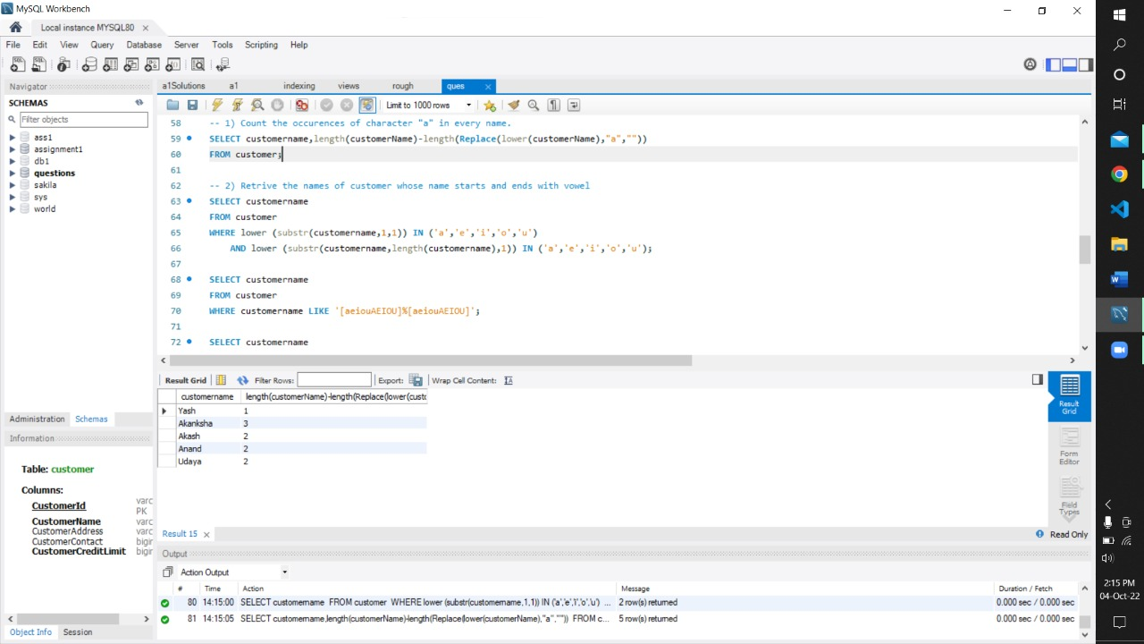

-- 2) Retrieve the names of customer whose name starts and ends with vowel.

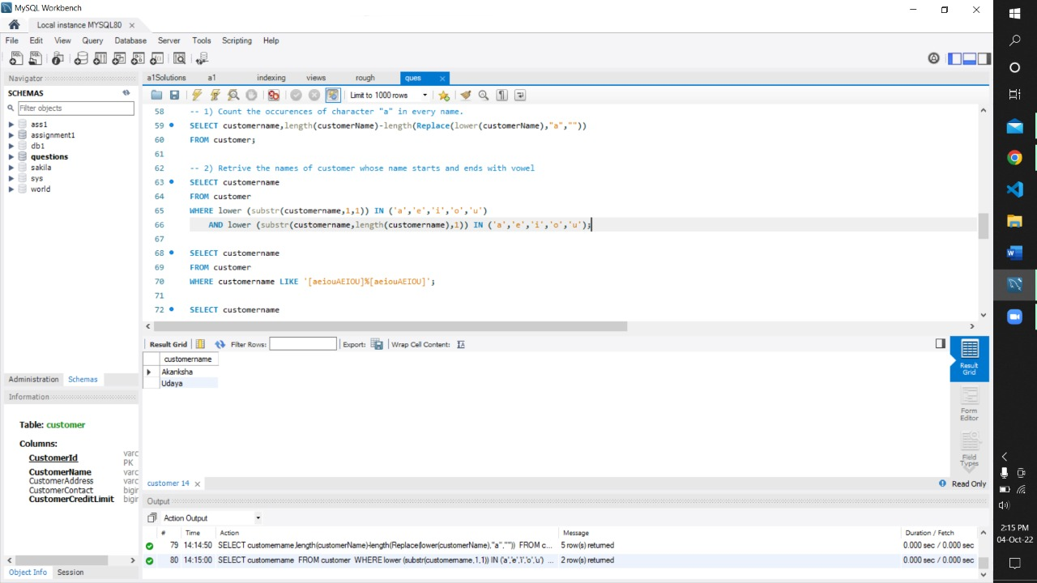

-- 3) List the customer name and product name of those who have ordered the highest quantity.

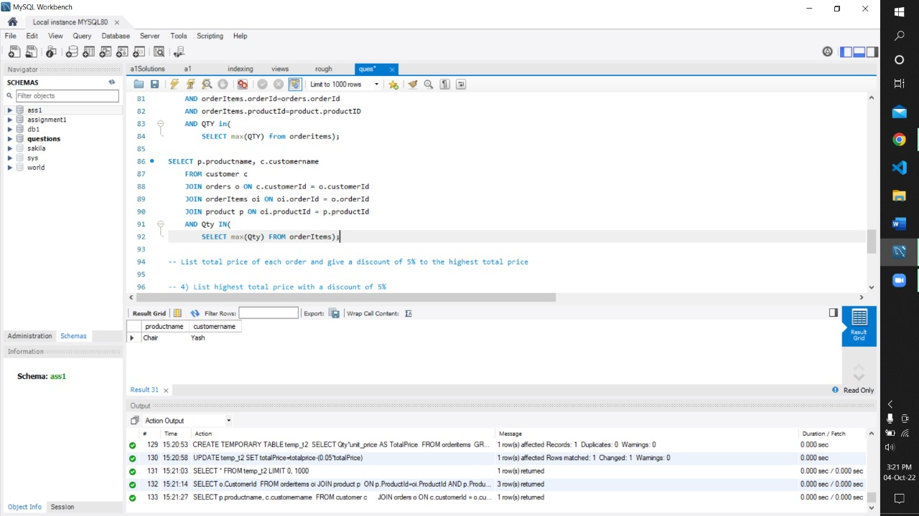

-- 4) List the highest total price with a discount of 5%.

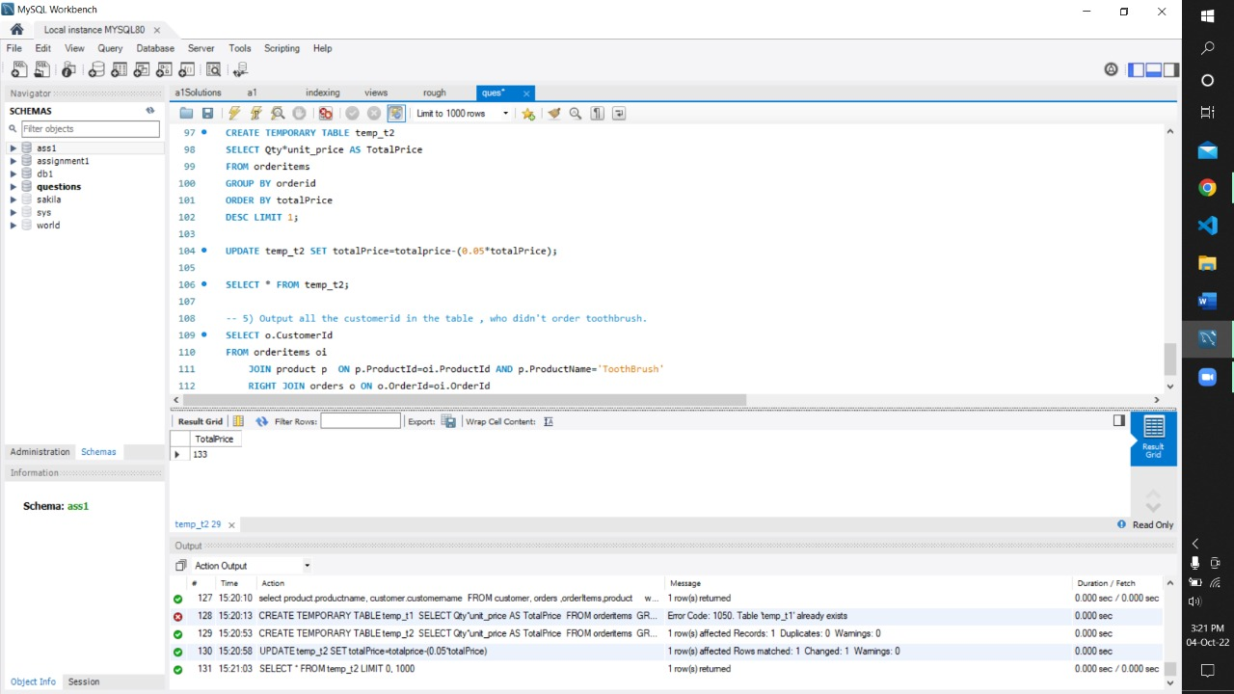

-- 5) Output all the customer id in the table who didn't order toothbrush.

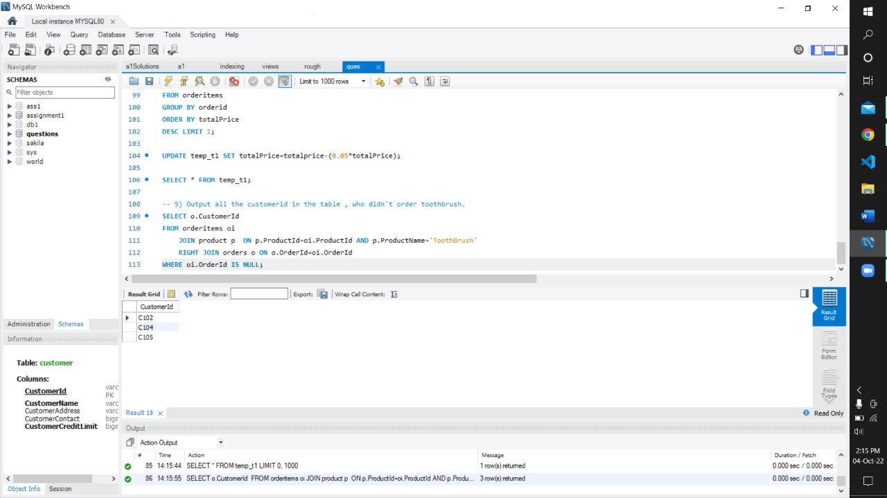

**Solutions:**

-- 1) Count the occurrences of character "a" in every name. List customer name and count of occurrences.

SELECT customerName, length(customerName)-length(Replace(lower(customerName),"a",""))

FROM customer;

-- 2) Retrieve the names of customer whose name starts and ends with vowel.

SELECT customername FROM customer

WHERE lower (substr(customername,1,1)) IN ('a','e','i','o','u')

AND lower (substr(customername,length(customername),1)) IN ('a','e','i','o','u');

**\*\*\*\*\*\*OR\*\*\*\*\*\*\*\*\*\*\*\*\*\*\*\*\*\*\*\*\*\*\*\*\*\***

SELECT customername FROM customer

WHERE LEFT(customername , 1) IN ('a','e','i','o','u')

AND RIGHT(customername,1) IN ('a','e','i','o','u');

-- 3) List the customer name and product name of those who have ordered the highest quantity

SELECT p.productname, c.customername

FROM customer c

JOIN orders o ON c.customerId = o.customerId

JOIN orderItems oi ON oi.orderId = o.orderId

JOIN product p ON oi.productId = p.productId

AND Qty IN(

SELECT max(Qty) FROM orderItems);

-- 4) List highest total price with a discount of 5%

CREATE TEMPORARY TABLE temp_t1

SELECT Qty*unit_price AS TotalPrice

FROM orderitems

GROUP BY orderid

ORDER BY totalPrice

DESC LIMIT 1;

UPDATE temp_t1 SET totalPrice=totalprice-(0.05*totalPrice);

SELECT * FROM temp_t1;

-- 5) Output all the customer id in the table who didn't order toothbrush.

SELECT o.CustomerId FROM orderitems oi

JOIN product p ON p.ProductId=oi.ProductId AND p.ProductName='ToothBrush'

RIGHT JOIN orders o ON o.OrderId=oi.OrderId

WHERE oi.OrderId IS NULL;